**2.1 Introduction**

Smart health bracelets have emerged as a sophisticated and popular wearable technology in recent years, designed to monitor and track various aspects of health and wellness. These devices incorporate advanced sensors, algorithms, and to collect and analyse data on physical activity, sleep patterns, heart rate, and stress levels, among other metrics. As such, they have attracted significant interest from researchers in various fields, including medicine, public health, and psychology, among others.

This literature study seeks to provide a comprehensive overview of the current state of research on smart health bracelets, exploring the effectiveness of these devices for promoting health and wellness outcomes. Specifically, we will examine the use of smart health bracelets for enhancing physical activity, improving sleep quality, reducing stress levels, and managing chronic conditions, such as diabetes and hypertension. We will also explore the ethical considerations and limitations of these devices, including issues related to data privacy, security, accuracy, and user engagement.

Research has shown that smart health bracelets can be effective in increasing daily step counts, promoting exercise adherence, and improving cardiovascular health. They have also been shown to improve sleep quality and reduce sleep disturbances among individuals with sleep disorders. Additionally, smart health bracelets have the potential to improve chronic disease management by tracking and monitoring symptoms and providing personalized coaching and feedback to users.

Despite their potential benefits, the use of smart health bracelets also raises important ethical considerations related to data privacy and security. Ensuring the accuracy and reliability of the data collected is another important consideration. Additionally, the potential for user engagement to decline over time is a limitation that needs to be addressed.

Overall, this literature study provides a nuanced understanding of the state of research on smart health bracelets, highlighting the potential benefits and challenges of their use in promoting health and wellness outcomes. By synthesizing the existing literature, we can identify gaps in our understanding and identify areas for future research.

**2.2 Review system requirements**

**2.2.1 Data collection**

Retrieving data is an essential part of any project development process, and it involves various methods such as browsing the internet, reviewing past research studies, consulting with knowledgeable friends, and utilising lectures and seminars as a reference. These methods of information gathering can provide a solid foundation of knowledge that can be leveraged to create innovative products with unique value propositions.

In this particular case, the process of data retrieval has led to the discovery of several smart health bracelets that share similar scopes and functions, and which can be used as a guide for developing a new smart health bracelet. By examining these existing products, designers and developers can gain insights into the features and functionalities that have been successful in the market. This can help them develop their own unique approach and innovative features that differentiate their product from the competition.

It's important to note, however, that simply copying what already exists is not the best approach. Instead, the information gained from existing products should be used as inspiration to develop new and unique features and functionalities that provide significant value to the target market. The ultimate goal is to create a product that stands out in the market and provides customers with a solution that meets their needs and exceeds their expectations.

In conclusion, the process of data retrieval is critical in the development of any product. Examining existing products and learning from them can provide valuable insights into what works and what doesn't work in the market. It's important to use this information as inspiration to develop new and innovative features that differentiate your product from the competition and provide unique value to customers.

**2.2.2  Observing existing smart health bracelet**

**2.2.2.1 Mi band**

The Mi Band 6 is a popular smart health bracelet developed by Xiaomi. It is the latest model in the Mi Band series, released in 2021, and has gained a reputation for its impressive specifications.

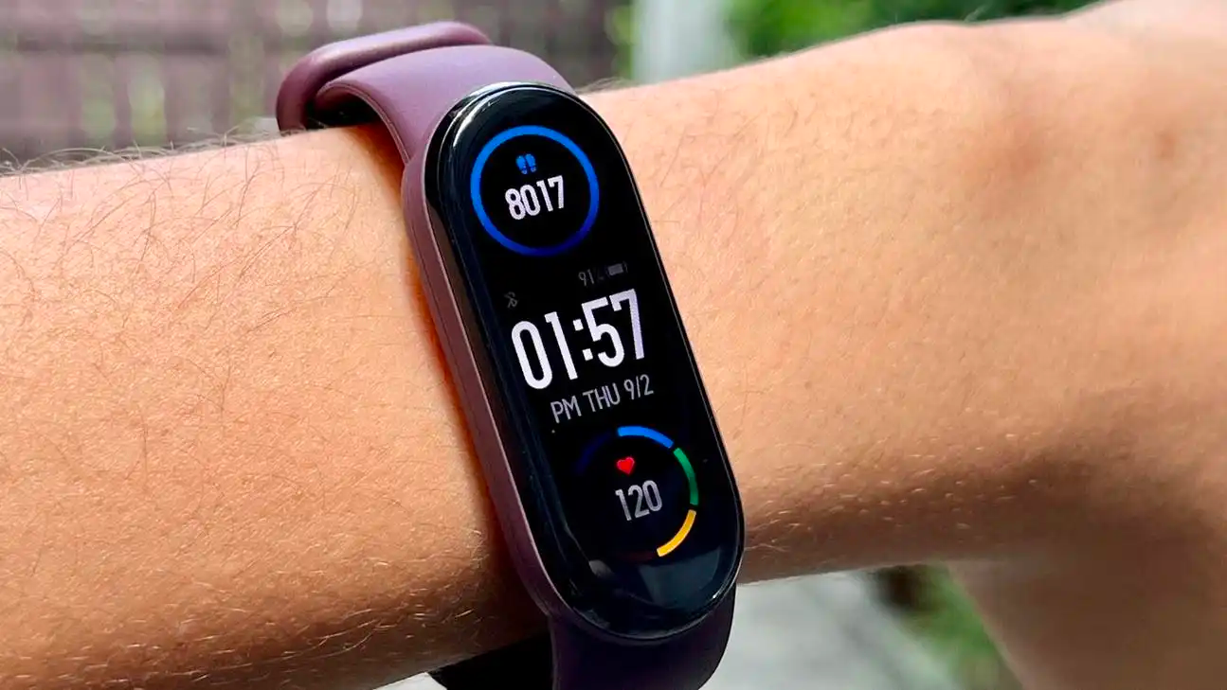

One of the Mi Band 6's most notable features is its large 1.56-inch AMOLED display with a resolution of 152 x 486 pixels. This is a significant upgrade from its predecessor, the Mi Band 5, which featured a 1.1-inch display. The Mi Band 6's larger display gives users more screen real estate to view health and fitness data, notifications, and other information.

The Mi Band 6 also has great battery life with up to 14 days of use on a single charge. It has 30 fitness modes, including yoga, rowing machine, and HIIT, allowing users to track a variety of physical activities. The device also has a built-in heart rate monitor that provides real-time heart rate data during your workout and throughout the day.

Besides fitness tracking, the Mi Band 6 has several other features that make it a versatile smart health bracelet. It has a sleep tracking feature that monitors a user's sleep patterns and provides insight into sleep quality. The device can also be used to control music playback on connected devices, receive notifications from smartphones, and monitor menstrual cycles for female users.

Overall, the Mi Band 6 is an impressive smart health bracelet that offers a range of features that allow users to monitor and improve their health and fitness. Large displays, long battery life, and a wealth of fitness tracking modes make them popular with consumers looking for a reliable and versatile wearable device.

**2.2.2.2 Amazfit gts**

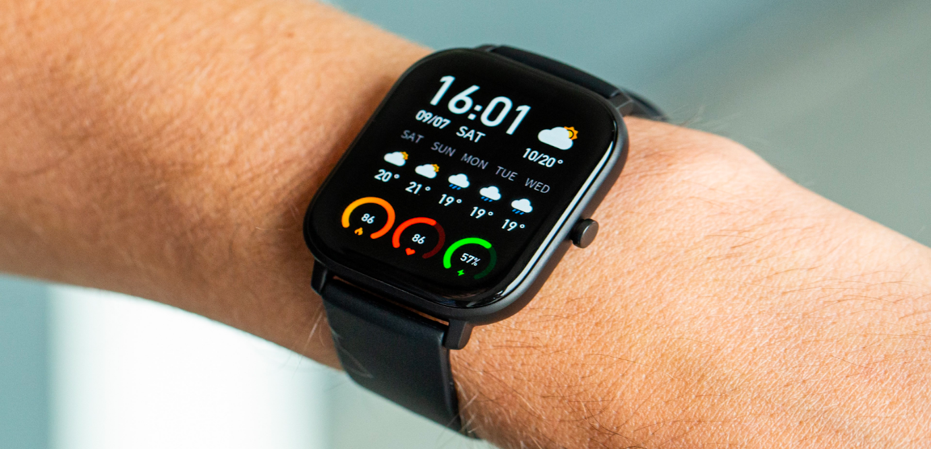

The Amazfit GTS is a smartwatch from Chinese electronics group Huami. It features a 1.65-inch AMOLED display with a resolution of 348 x 442 pixels and an always-on display. The watch has a slim 9.4mm aluminum alloy case and a 20mm interchangeable strap. Amazfit GTS is also 5ATM waterproof, making it suitable for swimming and water sports.

In terms of sensors, the Amazfit GTS includes a BioTracker PPG optical tracking sensor, a 6-axis accelerometer, a 3-axis geomagnetic sensor, a barometric pressure sensor and an ambient light sensor. This array of sensors allows the watch to track various fitness and health data. Additionally, the watch is equipped with Bluetooth 5.0 BLE and GPS+GLONASS connectivity, with NFC support on select models.

Amazfit GTS is equipped with a 220mAh lithium-ion polymer battery that can last up to 14 days on a single charge. In simple watch mode, the battery lasts up to 46 days on a single charge. With heart rate monitoring, sleep monitoring, and 12 different sport modes, this watch is perfect for fitness enthusiasts looking to track their workouts and overall health. In addition, the watch offers call and message notifications, music control, weather forecast, alarm clock, stopwatch, and find my phone.

Overall, the Amazfit GTS is a versatile smartwatch that can be used for many purposes. It's lightweight, stylish, and comes with a long-lasting battery that's perfect for on-the-go use. With comprehensive health and fitness tracking features and other useful features like call and message notifications, the Amazfit GTS is a great option for those who want a watch that can do it all.

**2.2.2.2 Realme band 2**

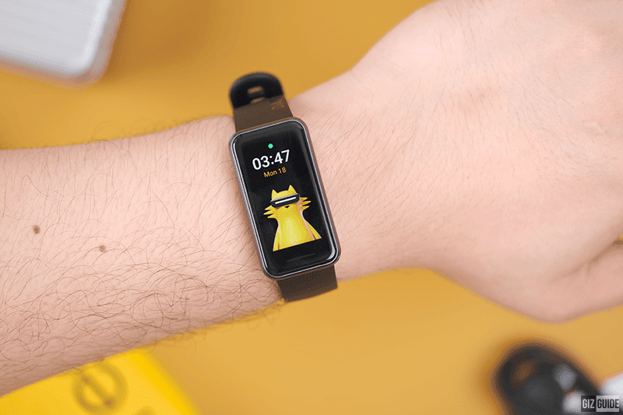

The Realme Band 2 is a fitness tracker from Chinese smartphone maker Realme. It features a 1.4-inch color touchscreen display with a resolution of 167 x 320 pixels and offers a large, easy-to-use interface for fitness tracking. The device is equipped with a 3-axis accelerometer, heart rate sensor, and blood oxygen (SpO2) sensor to track various health and fitness metrics.

Realme Band 2 comes with a 204mAh battery that lasts up to 12 days on a single charge, making it ideal for long-term use without frequent charging. It also has Bluetooth 5.1 for wireless connectivity and can be paired with Android and iOS devices via the Realme Link app. For those who enjoy water sports and activities, Realme Band 2 is IP68 water and dust resistant. This allows it to be submerged in water up to 1.5 meters deep for up to 30 minutes without damage.

When it comes to health and fitness tracking, Realme Band 2 offers comprehensive features such as heart rate monitoring, sleep tracking, blood oxygen monitoring, step counting, distance traveled, and calories burned. It also includes 90 selectable sport modes that provide real-time workout tracking.

In addition to health and fitness tracking features, the Realme Band 2 has some other useful features. These include call and message notifications, music control, camera control, weather forecast, and find phone.

Overall, the Realme Band 2 is an affordable, feature-packed fitness tracker that offers excellent value for money.It features a large color touchscreen display, long battery life, and comprehensive health and fitness tracking. This makes it a great choice for those looking for an affordable, high-performance fitness tracker.

**2.3  The Comparison Of The Advantages And Disadvantages of The Existing System**

|  |  |  |  |
| --- | --- | --- | --- |
| **Smart health bracelet name** | **Advantages** | **Disadvantages** | **References** |
| Mi band 6 | ·  Way affordable compared to other devices    ·  Lightweight and very comfortable to wear for long periods time      ·  Includes a Sp02 sensor for blood oxygen level monitoring    ·  There are more than 30 fitness modes available for comprehensive workout training and tracking | ·  Comes with smaller display compared to the Amazfit GTS and Realme Band 2    ·  Battery life span is shorter compared to the Amazfit GTS and Realme Band 2, it can lasts up to 14 days on a single charge per day | (Paradiso et al., n.d.) |
| Amazfit GTS | ·  Larger, higher quality AMOLED display compared to other devices    ·  Comes with more sensors such as barometric pressure sensor and geomagnetic sensor      ·  Longer battery life compared to other devices, up to 14 days on single charge    ·  Includes GPS + GLONASS connectivity and NFC support on select models | ·  More expensive compared to other devices stated    ·  Larger and heavier compared to other devices | (*Amazfit GTS User Manual*, n.d.) |
| Realme band 2 | ·  Larger display compared to the Mi Band 6    ·  Includes a Sp02 sensor for blood oxygen level monitoring      ·  Comes with longer battery life compared to the Mi Band 6, up to 12 days on a single charge | ·  Display quality is lower compared to the Amazfit GTS and Mi Band 6    ·  No GPS or NFC support for mobile payments |  |